**3.3 Ingest or access data**

There are many, many different ways to ingest data into Fabric, or access external data from within Fabric. Here's a selection of the most common methods:

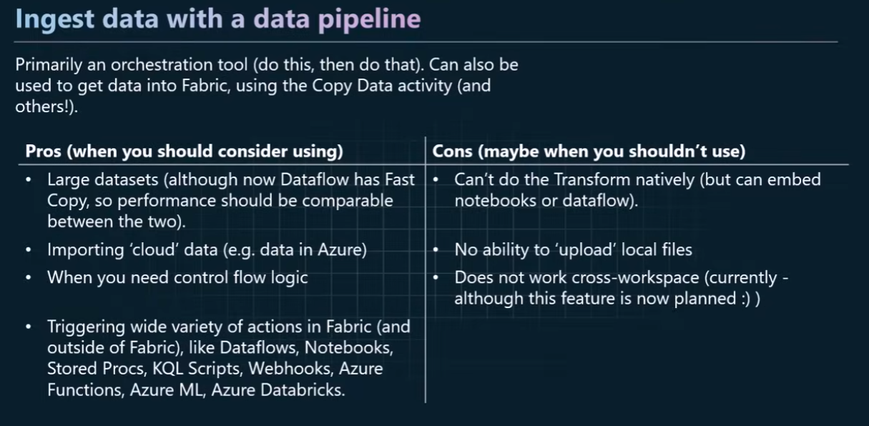**Data Pipeline:**

* Primarily an orchestration tool (do this, then do that). Can also be used to get data into Fabric, using the Copy Data activity (and others!).
* When to use Data Pipelines for Data Ingestion:
* Large datasets (although now Dataflow has Fast Copy, so performance *should* be comparable between the two).
* Ingesting ‘cloud’ data (e.g. data in Azure)
* When you need control flow logic - error handling, logging etc.
* Triggering wide variety of actions in Fabric (and outside of Fabric), like Dataflows, Notebooks, Stored Procs (Stored Procedures), KQL Scripts, Webhooks, Azure Functions, Azure ML, Azure Databricks.
* [On-premise data ingestion](https://learn.microsoft.com/en-us/fabric/data-factory/how-to-access-on-premises-data#using-on-premises-data-in-a-pipeline-preview)
* When NOT to use Data Pipelines for data ingestion:
* Can’t do the Transform natively (but can embed notebooks or dataflow).
* 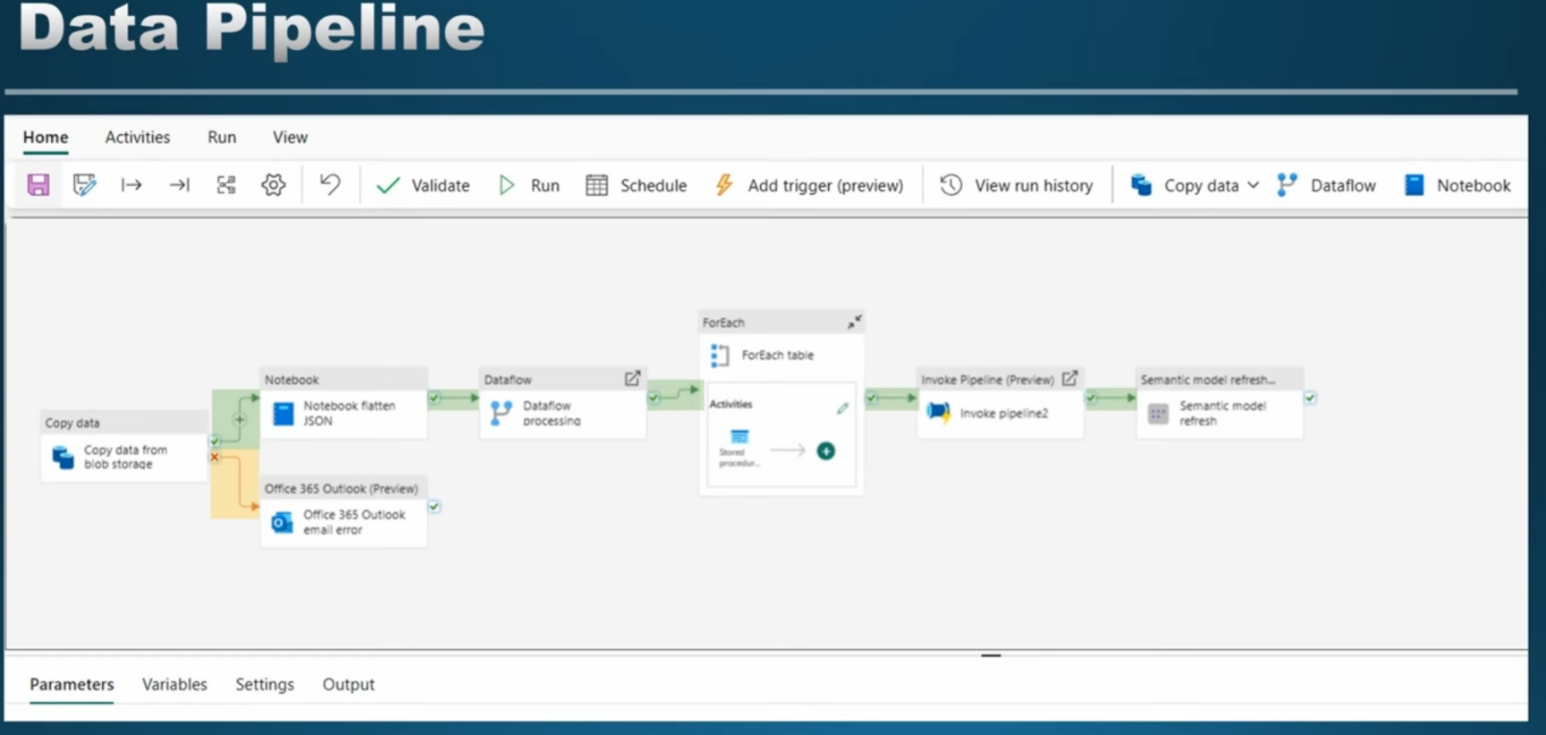No ability to ‘upload’ local files

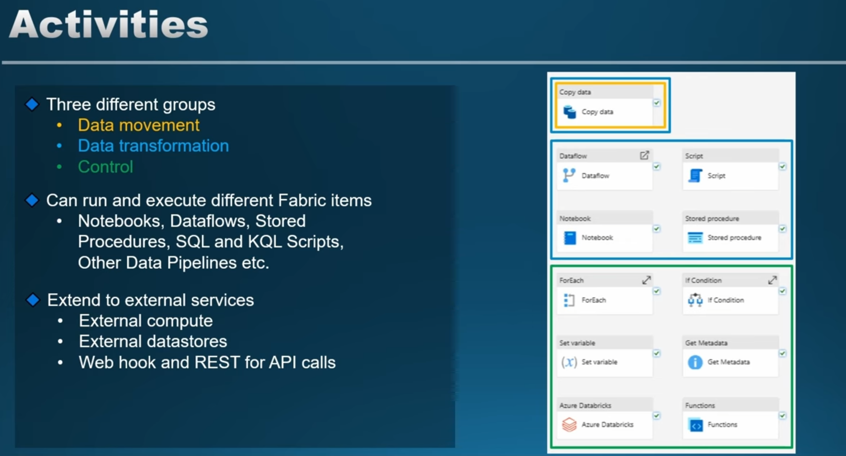

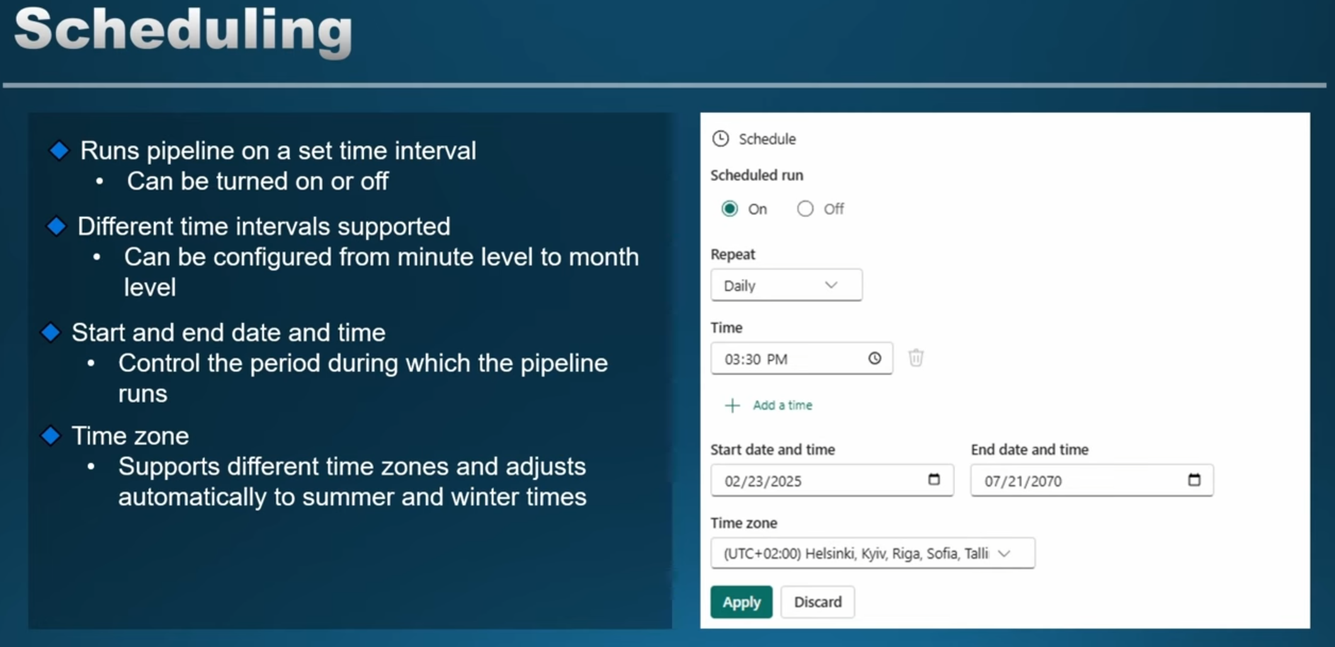

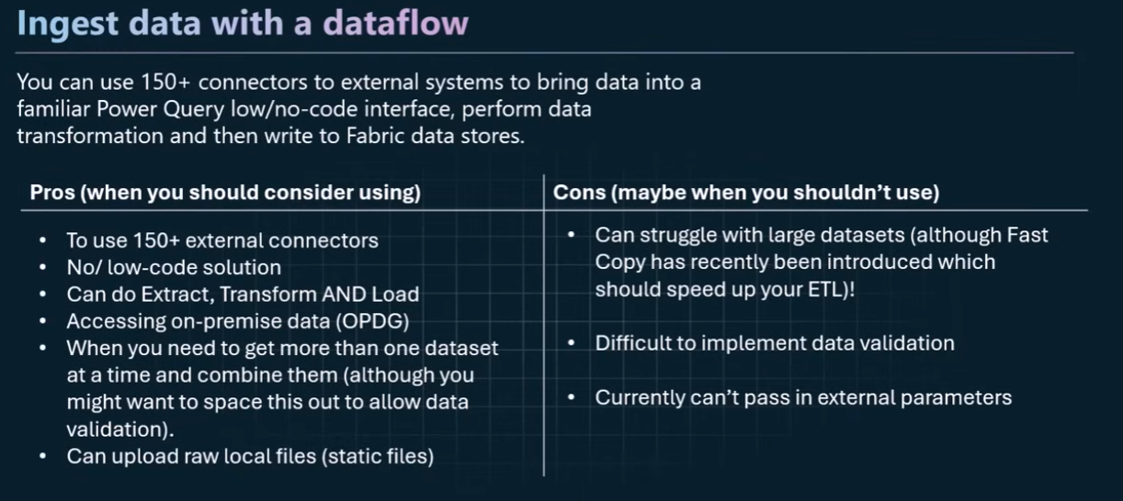**Dataflow Gen 2:**

* You can use 150+ connectors to external systems to bring data into a familiar Power Query low/no-code interface, perform data transformation and then write to Fabric data stores.
* When you might want to consider Dataflows:
* To use 150+ external connectors
* No/ low-code solution
* Can do Extract, Transform AND Load
* Can now do [Incremental Refresh](https://blog.fabric.microsoft.com/en-us/blog/announcing-public-preview-incremental-refresh-in-dataflows-gen2/) (currently in Preview)
* Accessing on-premise data
* When you need to get more than one dataset at a time and combine them (although you might want to space this out to allow data validation).
* When you might NOT want to use:
* When you are using a low capacity - Dataflows use the most capacity units of all the ingestion methods that means they are expensive).
* When you are ingesting a large dataset, you can use features like [Fast Copy](https://blog.fabric.microsoft.com/en-US/blog/fast-copy-in-dataflows-gen-2/) and Staging, but even with these, it might be better to use a Data Pipeline, a Copy Job, or a Notebook.
* Difficult to implement data validation

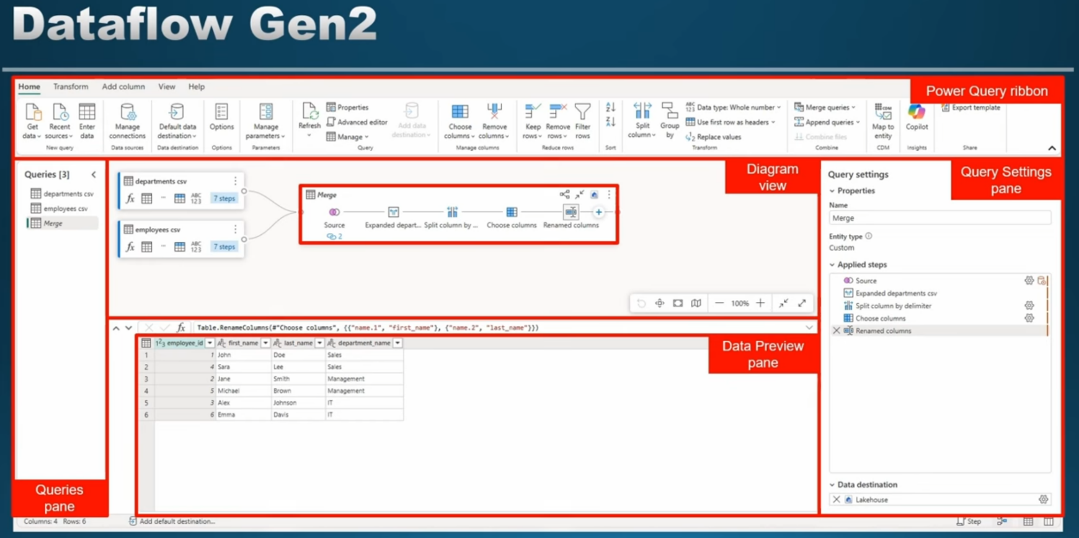

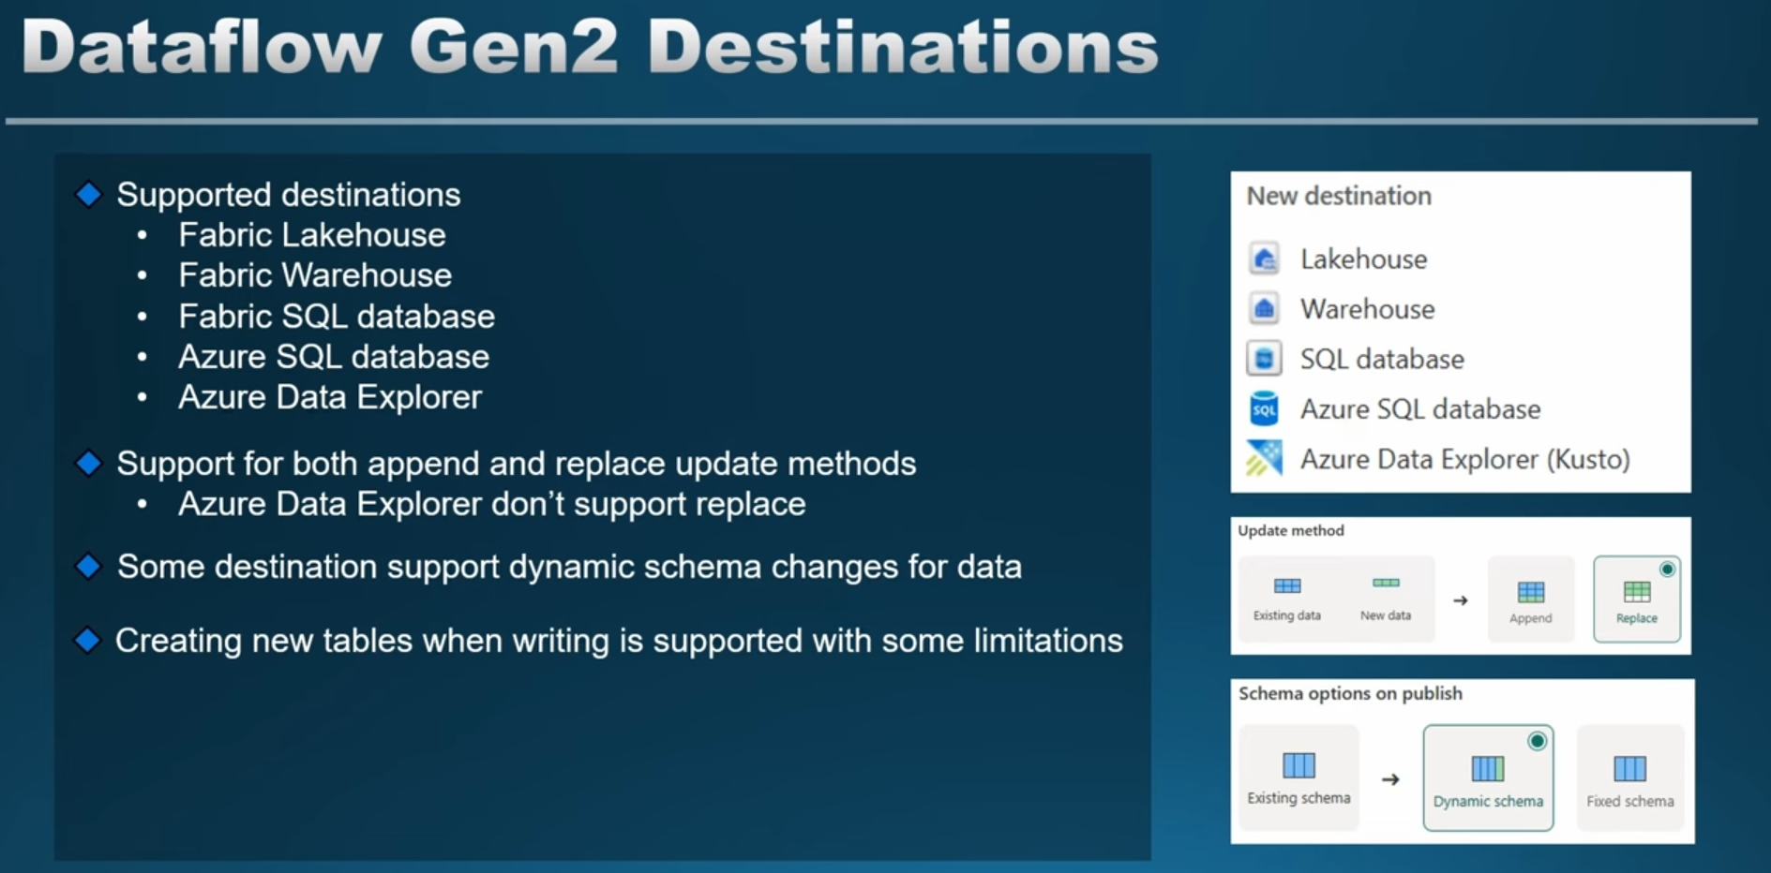

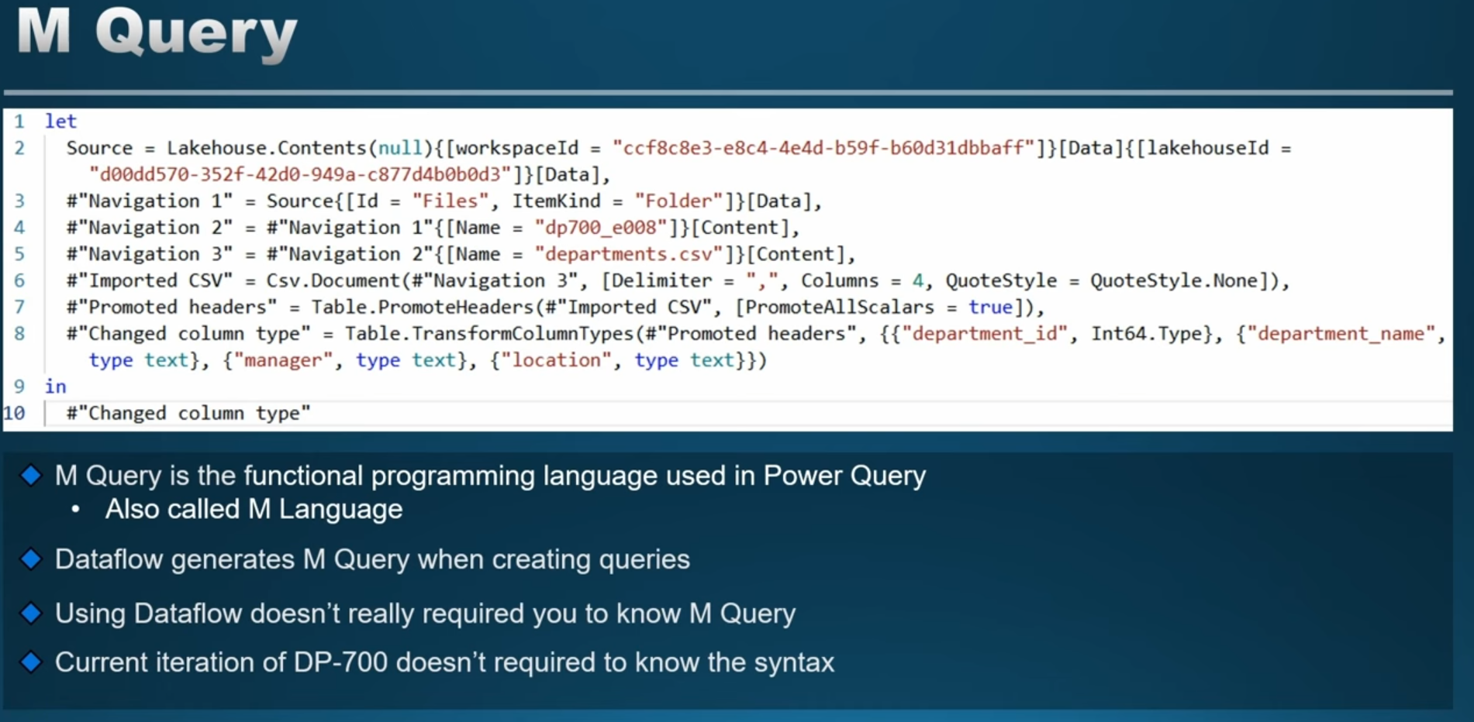

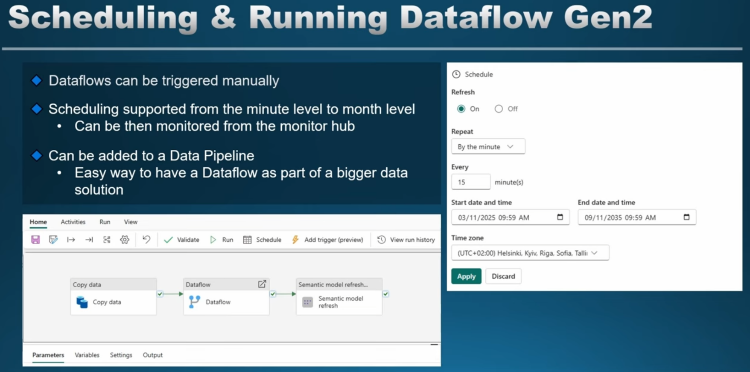

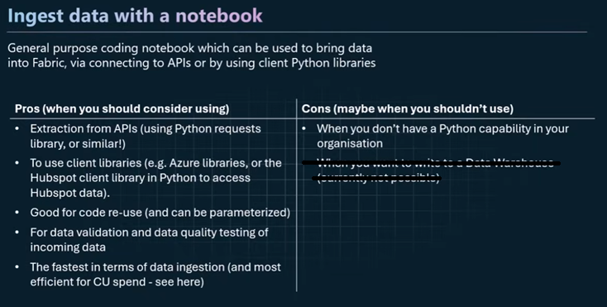**Notebooks:**

* General purpose coding notebook which can be used to bring data into Fabric, via connecting to APIs or by using Python client libraries
* When to use Notebooks for data ingestion:
* Extraction from APIs (using Python requests library, or similar!)
* To use client libraries (e.g. Azure libraries, or the Hubspot client library in Python to access Hubspot data).
* Good for code re-use (and can be parameterized)
* For data validation and data quality testing of incoming data
* The fastest in terms of data ingestion (and most efficient for CU spend - [see here](https://lucidbi.co/how-to-reduce-data-integration-costs-by-98))
* When NOT to use notebooks:
* When you don’t have a Python capability in your organisation

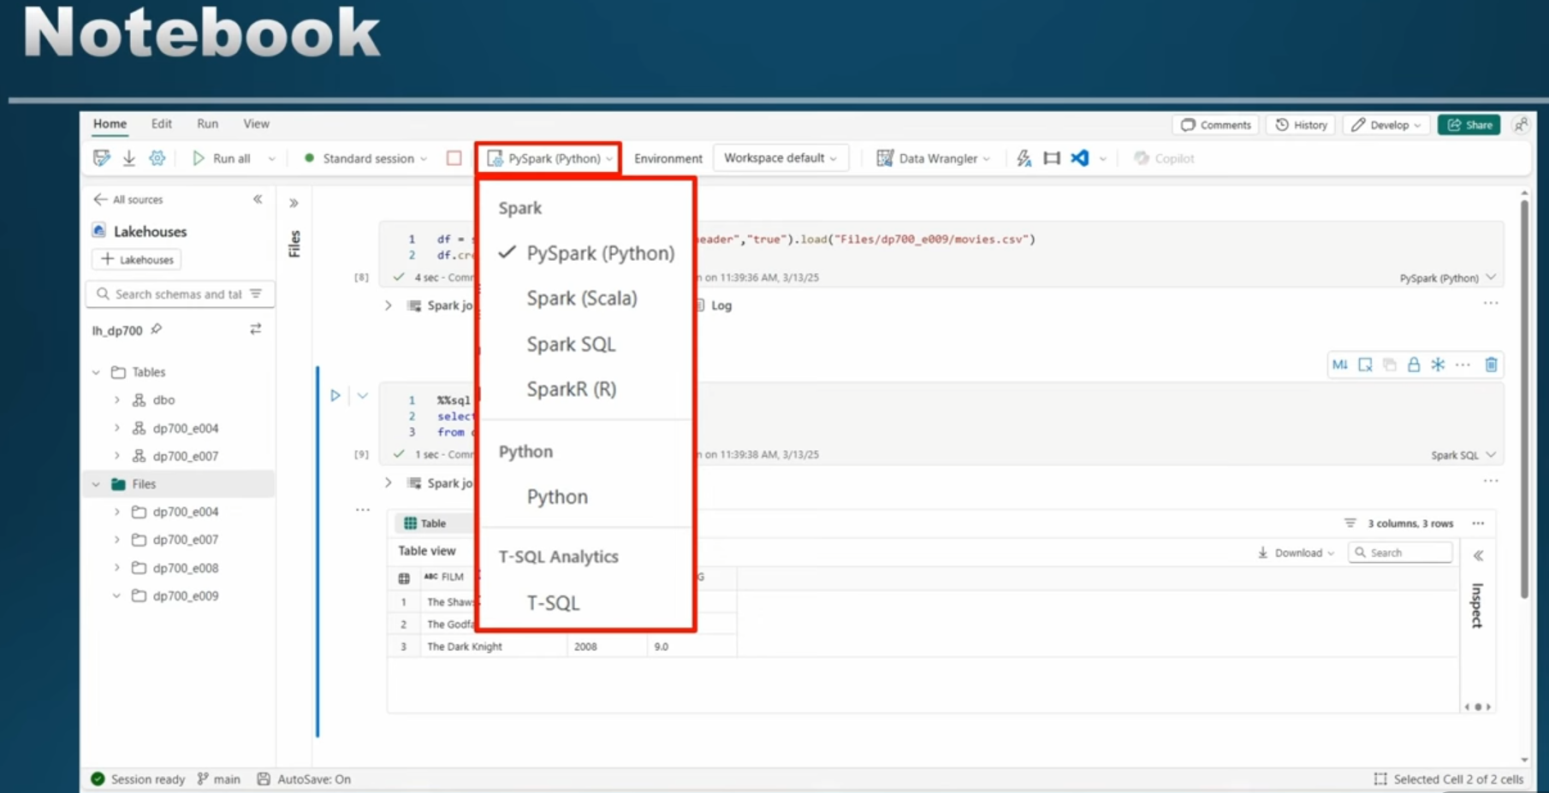

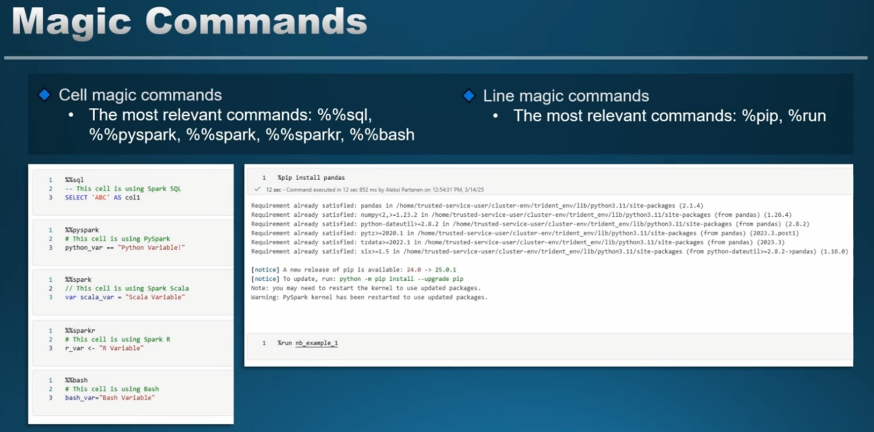

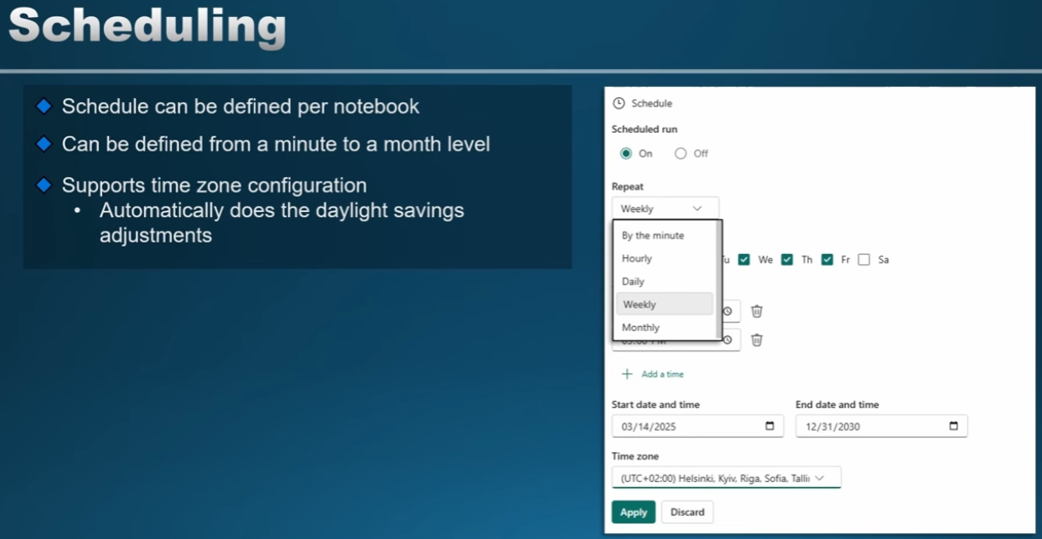

**Other:**

**T-SQL COPY INTO method:**

* You can ingest data from a ADLS Gen2 storage account into a Fabric Data Warehouse using the COPY INTO functionality.
* Only works currently for CSV and PARQUET, and your data must be in an ADLS Gen2 storage account.

**Copy Job (new! + preview):**

*Note: this is a preview feature and so might not be assessed in the exam.*

Similar to the Data Pipeline Copy Data activity, but now its own standalone Fabric item. It supports two 'modes'

* **Full copy mode**: Each copy job run copies all data from the source to the destination at once.
* **Incremental copy mode (for structured tables)**: The initial job run copies all table data, and subsequent job runs only copies changes since the last run. The changed data is appended to your destination store. ***Note: incremental copy only works for Fabric Data Warehouse destination currently****.*
* Works for the following data sources:
* Azure SQL DB
* On-premises SQL Server
* Fabric Warehouse
* Fabric Lakehouse
* Amazon S3
* Azure Data Lake Storage Gen2
* Azure Blob Storage
* Amazon RDS for SQL Server

**Accessing data**

Accessing data refers to methods that don't involve traditional data ingestion, but instead using Fabric features like Shortcuts and Mirroring.

**Shortcuts**

A shortcut allows you to access data in the following locations, from inside Fabric, without the need to physically ingest the data (but sometimes caching can help with latency). You can create an external shortcut to data in:

* ADLS (Azure Data Lake Storage) Gen2
* Amazon S3 (including now, Iceberg tables in Amazon S3)
* Other services that USE Amazon S3 for storage (like Cloudflare) Google Cloud Storage
* Dataverse

Shortcuts can be setup for individual files, but more commonly to a folder. If you create a shortcut to a ‘base’ folder, it will monitor and sync all files in subfolders.

As well as 'external' shortcuts, you can create shortcuts into a Lakehouse, or a KQL database from another Fabric data store.

* Be careful of cross-region egress fees. If your Fabric capacity is in UK-South region (for example), but your ADLS storage account, you will be charged for ‘cross-region’ egress fees ($0.01 per GB)
* OneLake shortcuts can now be created using the [Fabric REST API](https://learn.microsoft.com/en-us/rest/api/fabric/core/onelake-shortcuts)

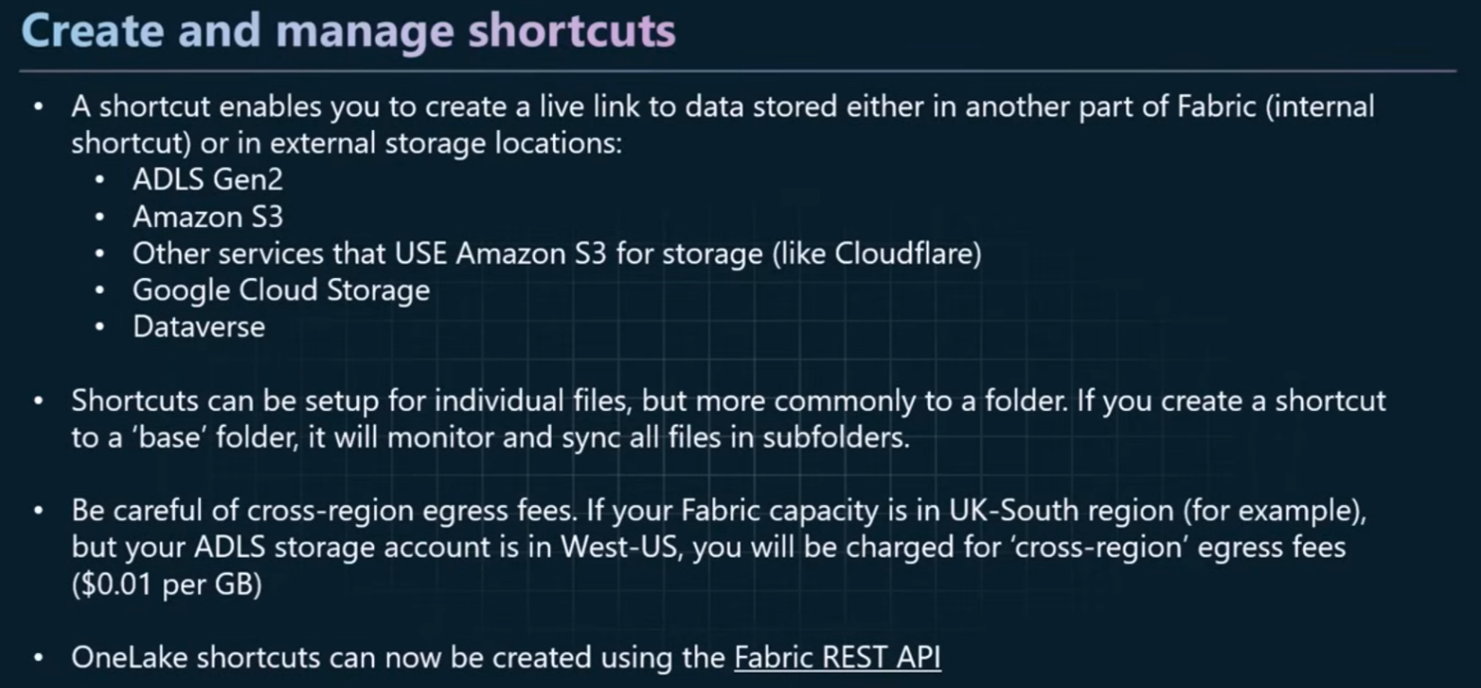

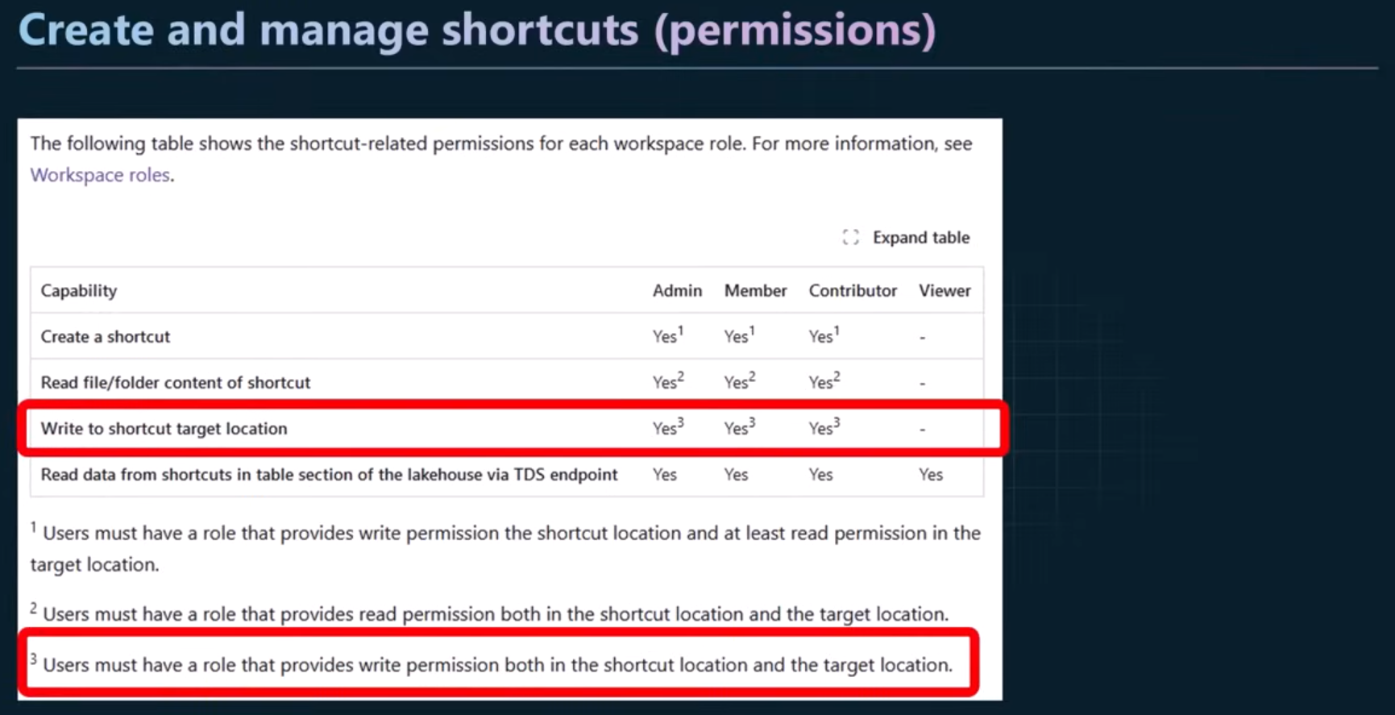

**Database Mirroring**

Mirroring can be used to access data from proprietary databases. The list of databases currently supported includes:

* Azure SQL database
* Azure Cosmos DB
* Snowflake

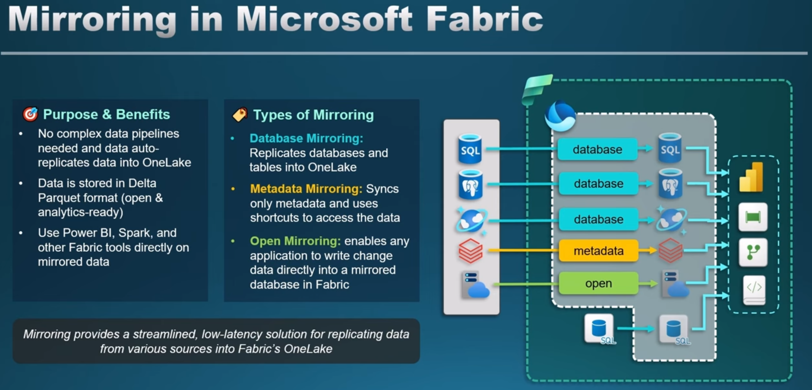On-premise databases currently not supported, but there is a [workaround](https://blog.fabric.microsoft.com/en-US/blog/mirroring-sql-server-database-to-fabric/).

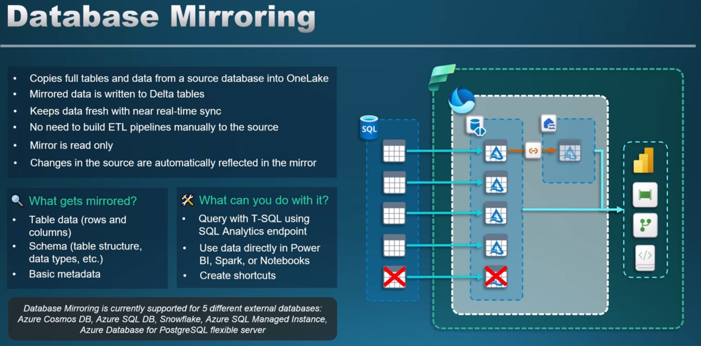

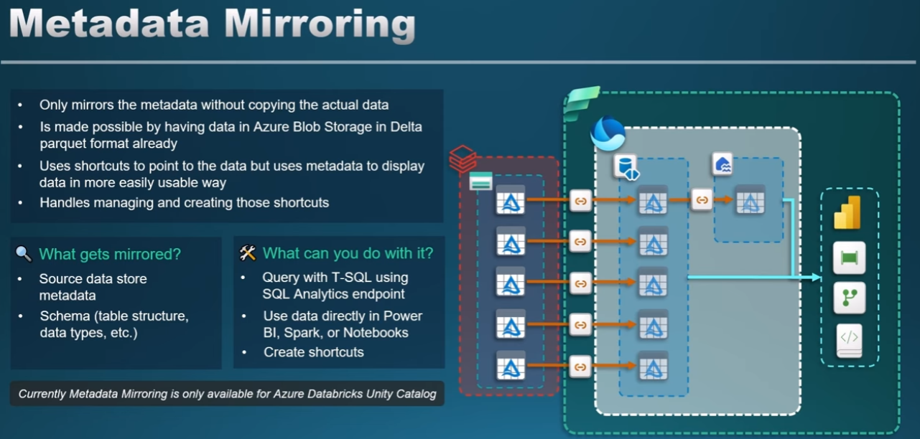

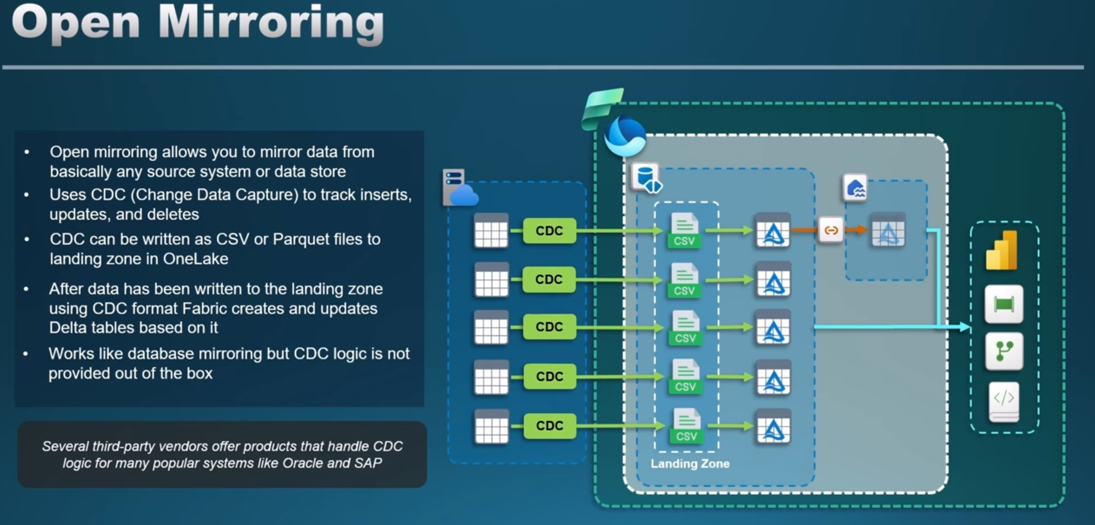

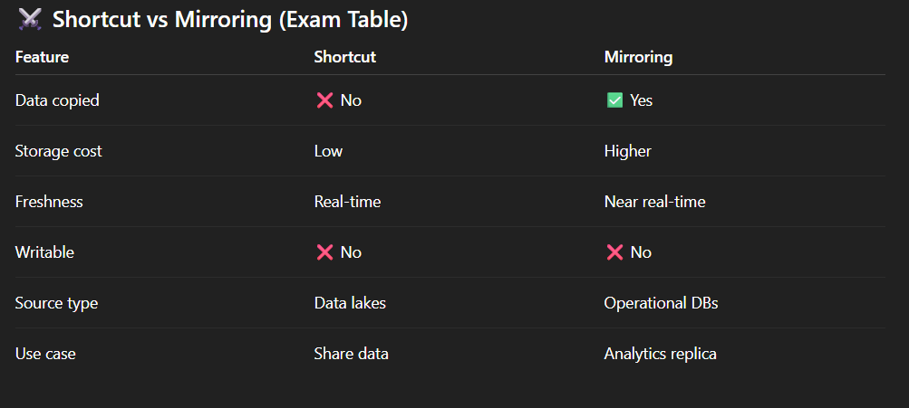

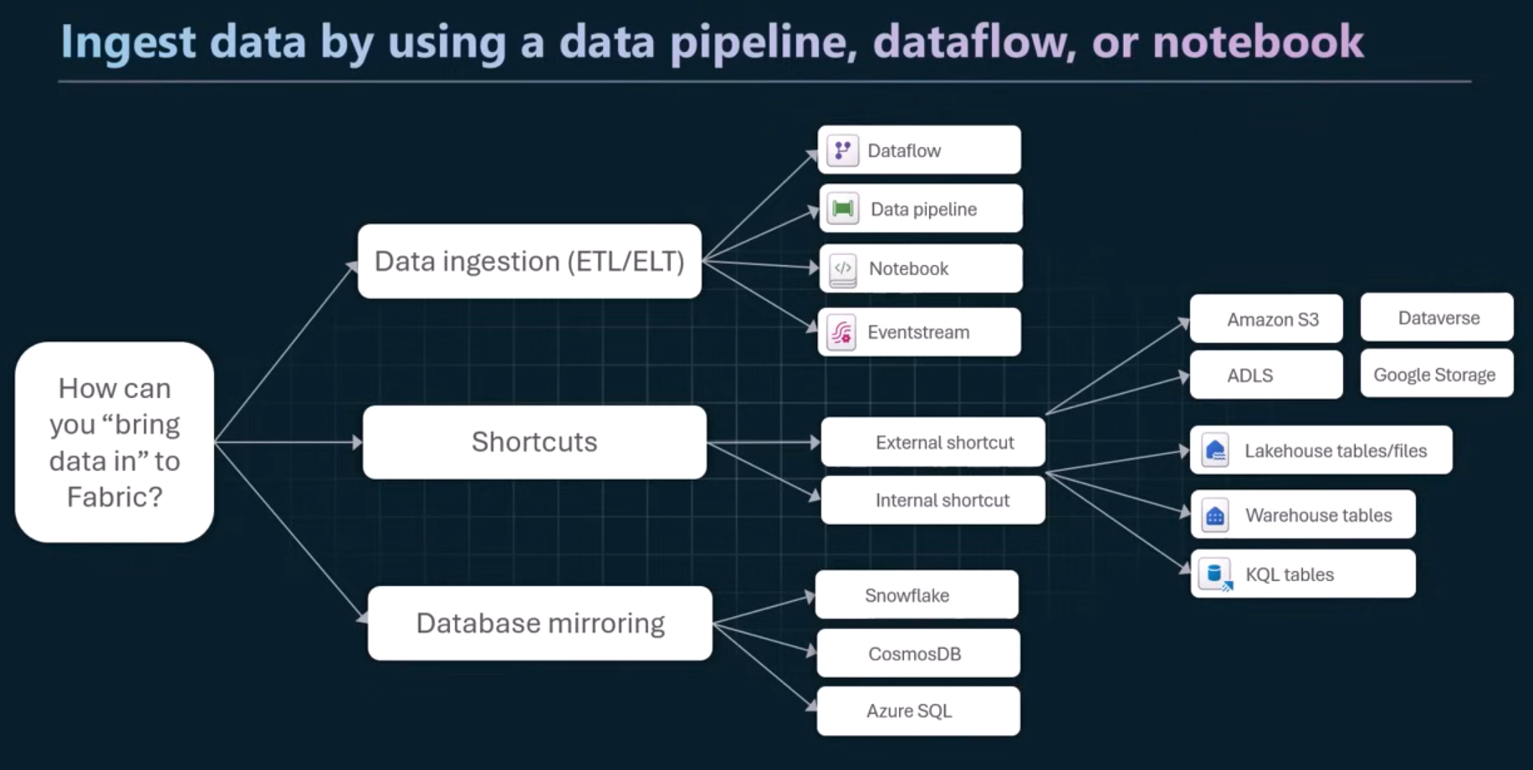**Summary**

**Dataflows vs Data Pipelines vs Shortcuts and other:**

